

**EXAMINATION TIME-TABLE GENERATION USING GRAPH COLORING**

**Teacher In-Charge:**           **Submitted By:**

Abhinav Gupta(17103215)

Dr. BHARAT GUPTA Pratham Dhawan(17103216)

Dr. SHIKHA JAIN Shubra Verma(17103219)

Sanskar Goyal(17103222)

**INTRODUCTION-**

Examinations in this country are an essential part of our education system. An educational institution is responsible for conducting examinations in a proper and responsible manner. It is an obvious fact that timetable generation is an extremely tedious task. This Algorithms and Problem Solving Project aims to tackle this problem.

**CONCEPTS USED**

**1.GRAPH COLOURING-**

Given an undirected graph and a number m, determine if the graph can be colored with at most m colors such that no two adjacent vertices of the graph are colored with same color. Here coloring of a graph means assignment of colors to all vertices. Subjects are allotted different colours according to their slots.

Input:  
1) A 2D array graph[V][V] where V is the number of vertices in graph and graph[V][V] is adjacency matrix representation of the graph. A value graph[i][j] is 1 if there is a direct edge from i to j, otherwise graph[i][j] is 0.  
2) An integer m which is maximum number of colors that can be used.

Output:  
An array color[V] that should have numbers from 1 to m. color[i] should represent the color assigned to the ith vertex.

**2.ALLOCATION USING MINIMUM RESOURCES-**

The concept of graph colouring is extended to include teachers as well. Suppose if there is only 1 teacher for multiple subjects(Present for Doubt Clearance) the schedule is designed according to the minimum number of teachers present.

**3.RANDOM SHUFFLING-** For smaller inputs we get exams in consecutive slots. As input increases the slots get further away and more effective scheduling is achieved. This is achieved through shuffle.

***FUNCTIONALITY USED-***

1.**WINDOWS LIBRARY**- Windows library is used in the code in order to include graphics.

**2.DELAY-** Pauses the program for some time.

**3.COMPARE AND COMPARE_NEW-** Utility functions used for sorting purposes.

**4.GRAPH_COLOURING_UTIL-** Performs the function of graph colouring by assigning an individual colour to each subject.

**5.PRINT_MATRIX-** Print the Adjacency Matrix.

**6.ADD_STUDENT_SUBJECTS-** Adds a student record by adding regular subjects ,backlogs and their count.

**7.ADD_TEACHER_SUBJECTS-** Adds a teacher record by specifying her department and subjects she teaches.

**8.PRINT_RENEWED_VECTOR-** Prints the final vector with subject code, it’s colour and number of students in that subject.

**9.PRINT_STUDENT_COUNT-** Prints the number of students in all the subjects.

**10. PRINT_TEACHER_LIST-** Prints the list of subjects along with teachers assigned to it.

**11. CHECK_SUFFICIENT_TEACHERS-** Checks whether teachers are sufficient for timetable generation.

**12.FORM_TIME_TABLE-** Prints the final timetable.

It includes printing subjects, teachers and rooms alloted to that subject.

**13.UTILITY FUNCTIONS-** Converttopairs ,modifysolution ,printpairs, generatefinalvector

**14.IS_SAFE-** Checks whether assigning a colour to a subject is safe or not.

***SCREENSHOTS***

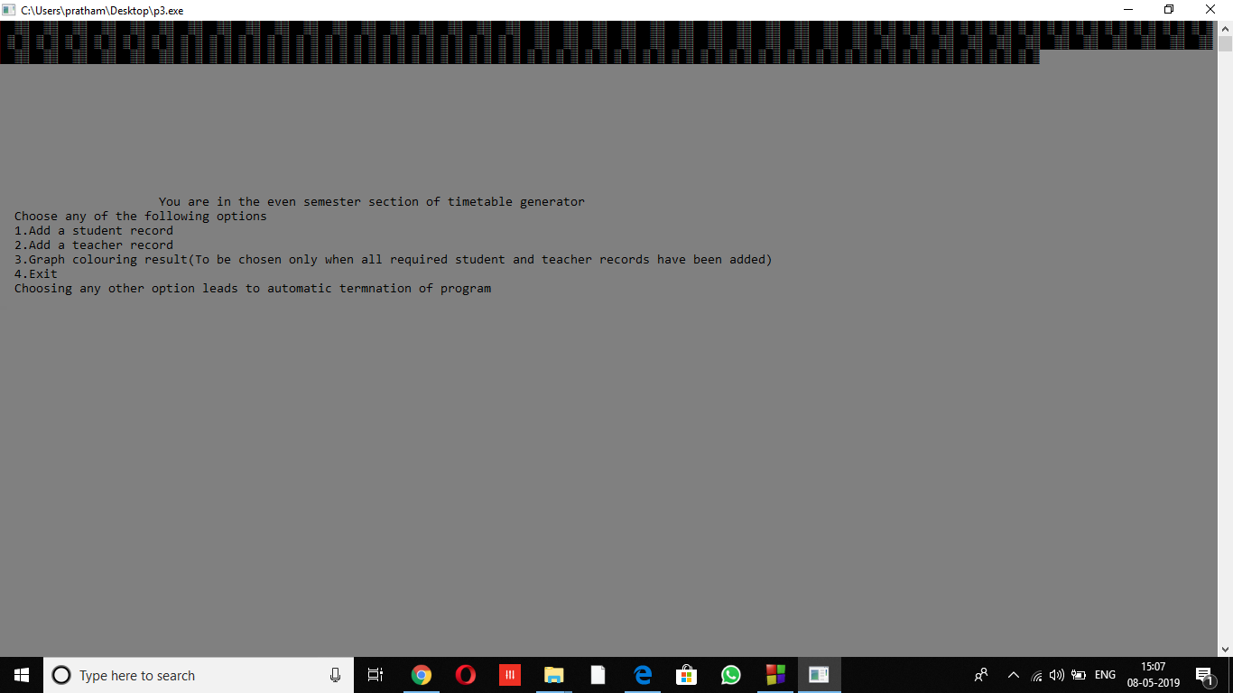

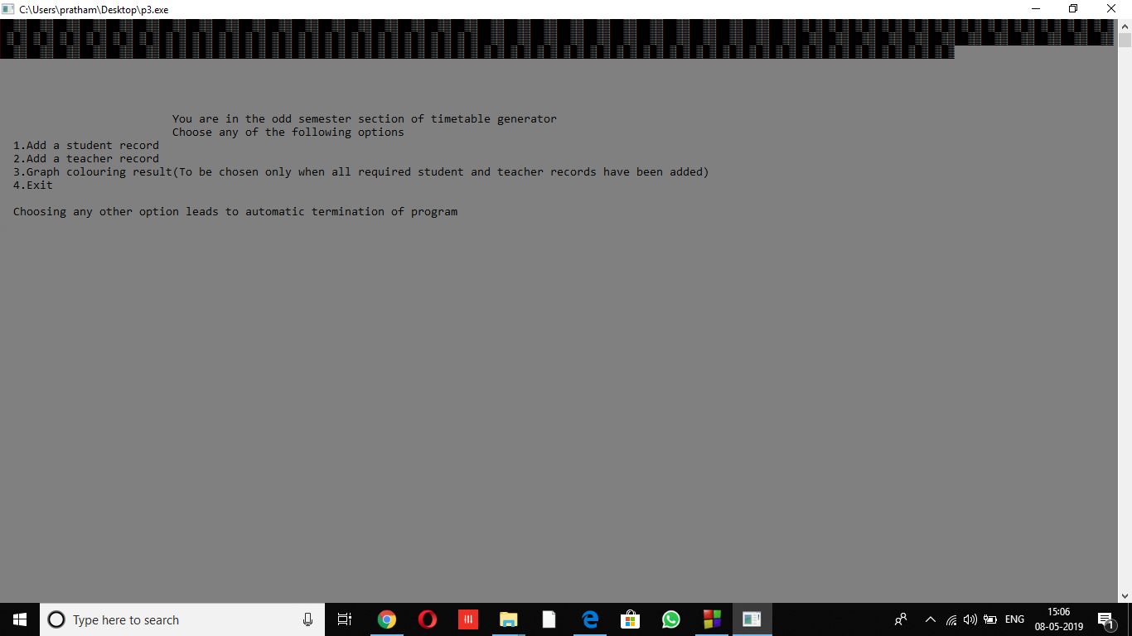

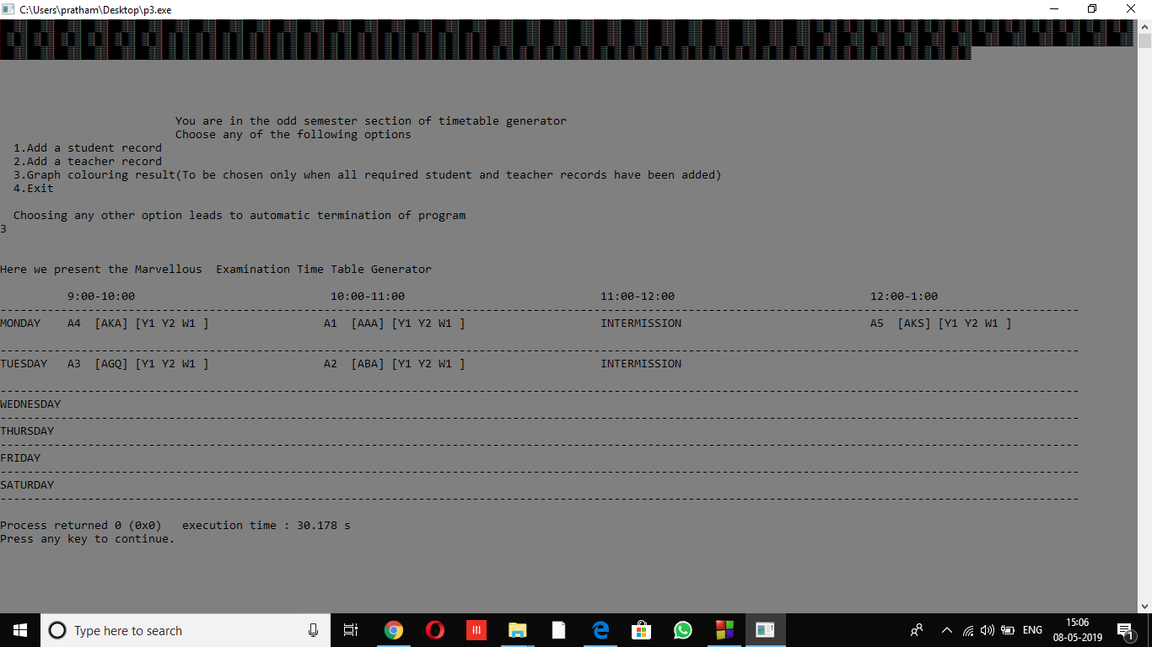

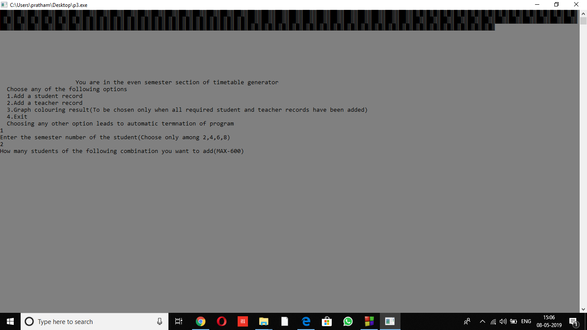

***Conclusion***

***Through this project, a solution to the difficult problem of examination time table scheduling is achieved.***

***Also this project aimed at using algorithms, in-built libraries and graphics for finding an efficient solution to this problem.s***